I have provided two architectural diagram, you need to identify which approach is better. You need to explain selected approach and pros and cons, etc. Approach 1: Return JSON only from Lexicon Compile Service(as per current implementation) and create Hyperscan DB file (per Lexicon Rule) at runtime in Lexicon Scan Engine (dataproc job) to process millions of communication messages to match text and raise alerts Approach 2: Return JSON and Hyperscan DB file both from Lexicon Compile Service and read Hyperscan DB file (per Lexicon Rule) Lexicon Scan Engine (dataproc job) to process millions of communication messages to match text and raise alerts containing compiled regular exp
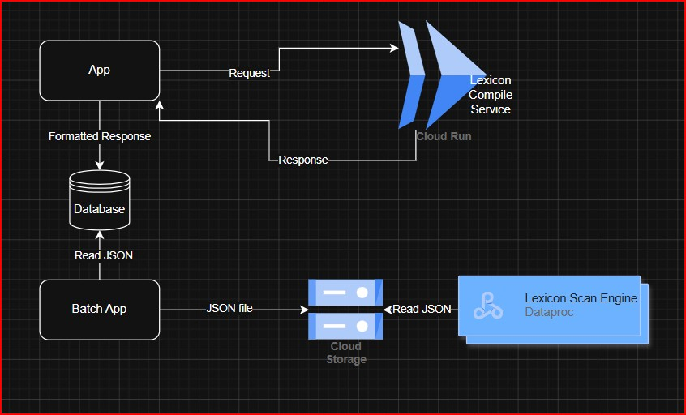

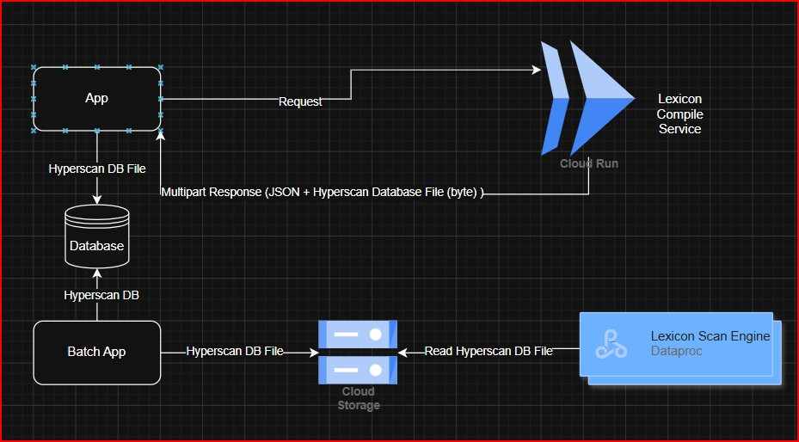

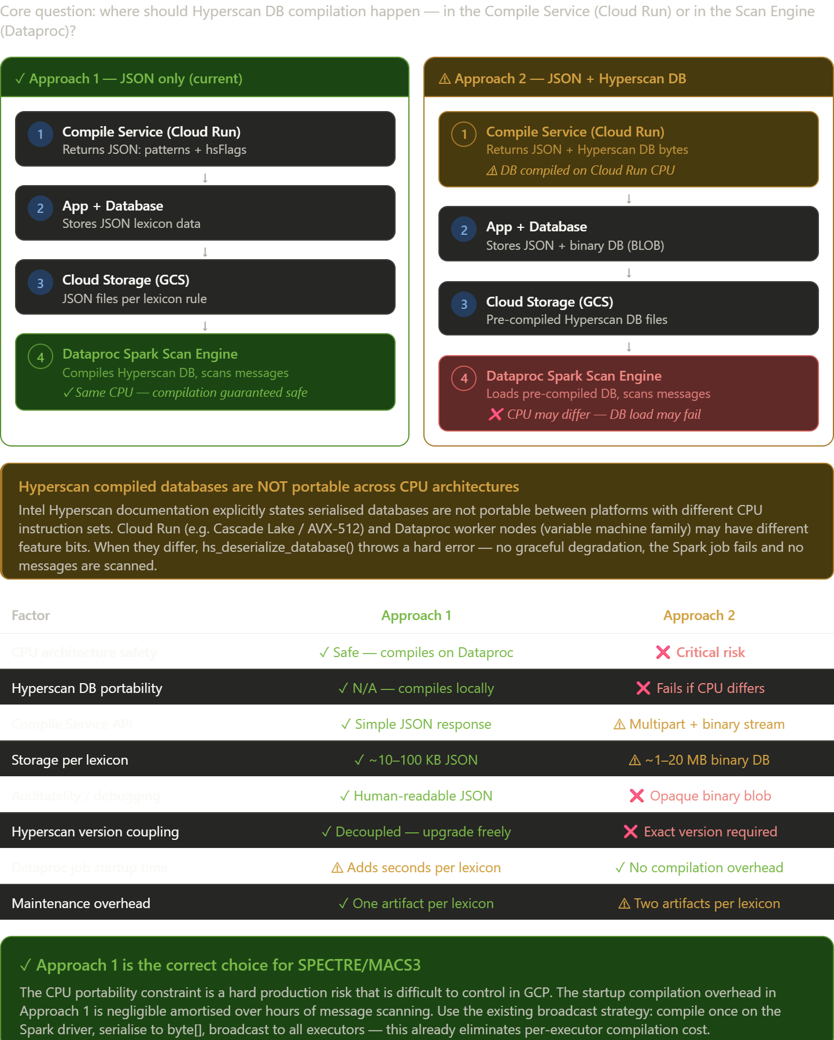

Approach 1 is the better choice. The visual comparison below shows why — then I'll explain every factor in detail.Here is the full analysis behind each decision point.

The decisive reason: Hyperscan compiled databases are CPU-specific
This is the fundamental blocker for Approach 2, documented explicitly in Intel's Hyperscan library:
"A database serialized by hs_serialize_database is NOT portable between platforms. Specifically it is not portable between processors of different architectures and may not be portable between different versions of the Hyperscan library."
In GCP the problem is concrete. Cloud Run allocates instances from its available pool — you may get Cascade Lake (AVX-512), Ice Lake, or even an N1 generation chip depending on availability. Dataproc worker nodes are independently configured. If the Compile Service produces a database compiled for AVX-512 instructions and it lands on a Dataproc worker that only has AVX2, hs_deserialize_database() throws a hard error — not a warning, not a degraded scan, a crash. Every message in that Spark partition goes unscanned and no alert is raised. For a compliance surveillance system this is a silent miss, which is exactly the failure mode you must never have.

Why the only real advantage of Approach 2 doesn't justify the risk
Approach 2's single genuine benefit is eliminating the Hyperscan compilation cost at Dataproc startup. That saving is real but tiny in context:
- Compiling a moderately complex lexicon (100–500 patterns) takes roughly 0.5–3 seconds on the Spark driver.
- With 50 lexicon rules that's 25–150 seconds of startup.
- A Dataproc job scanning millions of messages runs for hours. The compilation overhead is under 1% of total runtime.
The current broadcast strategy (compile once on the Spark driver → serialize to byte[] → broadcast to all executors) already eliminates the per-executor cost, so this overhead is genuinely minimal.

Approach 2 adds four new failure modes
Beyond the CPU risk, Approach 2 introduces problems that don't exist today:
Hyperscan version pinning. The serialised database format is tied to the exact Hyperscan library version. If you upgrade com.gliwka.hyperscan on Cloud Run, every pre-compiled DB in GCS immediately becomes invalid and must be regenerated. Approach 1 has no such coupling — the Compile Service and Dataproc can be upgraded independently.
Binary storage in the Database. Approach 2 requires storing multi-megabyte BLOB columns in the database alongside JSON. Binary DB files per lexicon are 1–20 MB versus 10–100 KB for JSON. That's 10–100x more storage for data that is harder to back up, migrate, or inspect.
Multipart API complexity. Returning application/octet-stream alongside JSON in a multipart response requires additional serialisation, streaming, and deserialization logic on both the Compile Service and the App. Every integration point becomes more fragile.
Two-artifact maintenance. Every time a lexicon term changes, you must regenerate both the JSON and the binary DB file, keep them in sync, and ensure the versions match. With Approach 1 there is only one artifact, and the Scan Engine always compiles the freshest patterns at job start.

When Approach 2 could be revisited (conditions that don't apply today)
There is a scenario where Approach 2 makes sense: if your organisation pins both Cloud Run and Dataproc to the exact same machine family and CPU generation (e.g. all n2-standard Cascade Lake, locked in Dataproc configuration), AND you pin the Hyperscan library version in both services, AND you have a CI/CD step that validates binary DB compatibility before promotion. Under those strict controls, the startup saving becomes a genuine operational win for jobs that run very frequently with large lexicons. None of those conditions are met in the current setup.

Summary
Approach 1 is correct for this system. Its only weakness — startup compilation time — is already addressed by the broadcast strategy and is negligible for batch scanning. Approach 2's only advantage does not outweigh a CPU portability risk that could silently suppress compliance alerts in production.

